Brett Anderson

Joseph McMurrough

CS 340 Final Project

# Overview

Our database is about juniors’ club volleyball. Volleyball clubs consist of multiple teams, each with multiple players and coaches. Each age group will have a team, and if there are multiple teams at an age group then they will be ranked by their level within the age. Each team will have multiple athletes, and each athlete can have multiple positions. Each team will have coaches, and each coach can have a position.

Our database allows for different teams at set age groups, as well as multiple teams at the same age group. Athletes can be added, and assigned to teams with multiple positions. Coaches can be added to teams as either a head coach or an assistant coach, and can be on more than one team. Our ER diagram shows that most of our connections are many to many.

In an effort to show versatility, we did some queries differently in various places. One update might use the ‘id’, where another looks up by matching multiple attributes. We also used a few aggregate functions, NOT IN queries, and even queries to fill in drop down boxes where useful. There are two separate pages set up, one for each of us. The PHP code checks which site it is on, and loads the appropriate database.

## Database Outline

The database contains tables for athletes, teams, coaches and positions. Each of the main entities has attributes in addition to a unique id. Athletes have first name, last name and age. Coaches have a first name and last name. Teams have names, age groups, and a level within the age group. Positions have a type. We have combined the positions of coaches and athletes, because it is conceivable that an athlete could also be a coach on a different team. Constraints exist on the team names being unique, and the coaches first and last name combination being unique.

Most of the relationships are many to may. Coaches can be on many teams, and teams can have many coaches. Athletes can be on many teams, and teams can have many athletes. Positions can have many coaches or athletes, and coaches and athletes can have multiple positions.

## Websites

Brett Anderson: <http://people.oregonstate.edu/~anderbre/vbphp.php>

Joseph McMurrough: <http://web.engr.oregonstate.edu/~mcmurroj/vbProj/vbphp.php>

## ER Diagram

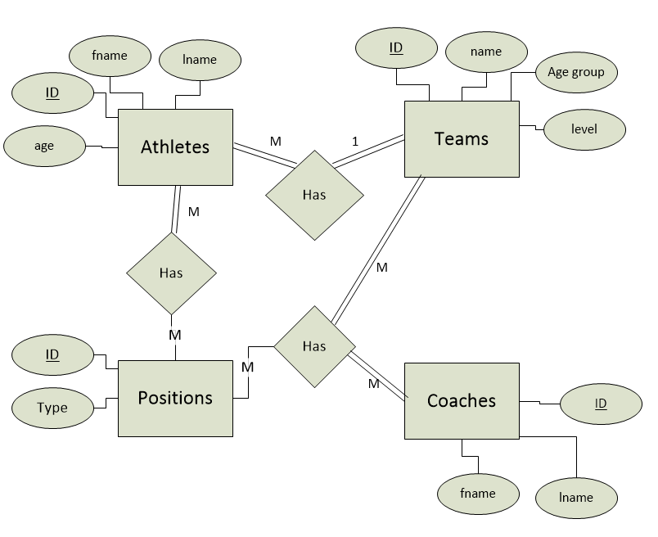

## Schema

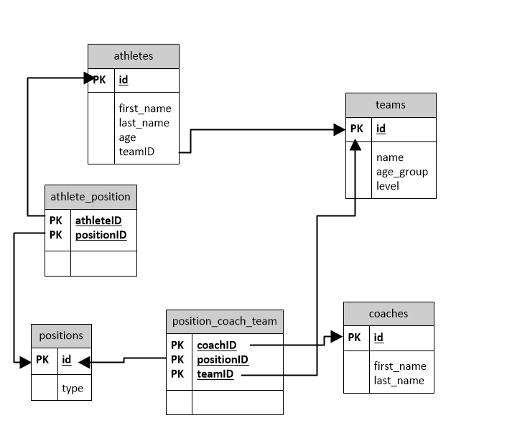

## SQL queries

The following queries were used in the interaction of our website and the database. [] indicate a variable that is filled in by the user.

-- COACHES.PHP QUERIES --

1. SELECT id, first_name, last_name FROM coaches ORDER BY last_name

2. SELECT coaches.first_name, coaches.last_name, teams.name, teams.age_group, teams.level, positions.type

FROM coaches LEFT JOIN position_coach_team ON position_coach_team.coachID = coaches.id

LEFT JOIN positions ON positions.id = position_coach_team.positionID

LEFT JOIN teams ON position_coach_team.teamID = teams.id

ORDER BY teams.age_group DESC

-- ADD_UP_COACH.PHP --

1. Update an existing coach’s name.

UPDATE coaches SET first_name=[first name], last_name=[last name] WHERE id=[id]

2. Add a new coach

INSERT INTO `coaches` (`first_name`,`last_name`) VALUES ([first name],[last name])

-- TEAMS.PHP --

1. SELECT teams.name, teams.age_group, teams.level, COUNT(athletes.id) AS players FROM teams

LEFT JOIN athletes ON athletes.teamID = teams.id

GROUP BY teams.name

ORDER BY teams.age_group DESC, teams.level ASC

-- ADD_UP_TEAM.PHP --

1. Update an existing team’s information

UPDATE teams SET name=[team name], age_group=[age group], level=[level] WHERE id=[team id]

2. Add a new team to the database

INSERT INTO `teams` (`name`,`age_group`, `level`) VALUES ([team name], [age group], [level])

2. SELECT id, name, age_group, level FROM teams ORDER BY age_group DESC, level ASC

-- ATHLETES.PHP QUERIES --

1. Selects althete: first name + last name + age, team: name

SELECT a.first_name, a.last_name, a.age, t.name FROM athletes a INNER JOIN teams t ON a.teamID = t.id ORDER BY t.name,a.last_name

2. All positions held by all athlete (even if empty).

SELECT a.first_name, a.last_name, t.name, p.type FROM athletes a Left JOIN athlete_position ap ON

ap.athleteID = a.id Left JOIN positions p ON

p.id = ap.positionID Left Join teams t ON a.teamID=t.id Order By t.name asc, a.last_name

3. DROP DOWN LIST: --Athlete's Team--

SELECT id, name FROM teams

-- ADD_UP+ATHLETE.PHP QUERIES --

1. Inserts new athlete into athletes table by first name, last name , age , and team ID

INSERT INTO `athletes` (`first_name`,`last_name`,`age`,`teamID`) VALUES ([first name], [last name], [age], [team id])

2. Updates team and age based on user input first name and last name combination

UPDATE athletes SET teamID=[team id], age=[age] WHERE first_name=[first name] AND last_name=[last name]

-- POSITIONS.PHP QUERIES --

1. Coach positions and team by position type

SELECT c.first_name, c.last_name, t.name, p.type FROM coaches c Left Join position_coach_team pct ON

pct.coachID = c.id Left Join teams t on t.id = pct.teamID Left Join positions p ON p.id=pct.positionID Order By p.type desc, t.name

2. All positions held by all athlete (even if empty).

SELECT a.first_name, a.last_name, t.name, p.type FROM athletes a Left JOIN athlete_position ap ON

ap.athleteID = a.id Left JOIN positions p ON

p.id = ap.positionID Left Join teams t ON a.teamID=t.id Order By t.name asc, a.last_name

3. DROP DOWN LIST: --Coach's Positions--

SELECT id, type FROM positions WHERE positions.type = 'Head Coach' OR positions.type = 'Assistant Coach'

4. DROP DOWN LIST: --Athlete's Positions--

SELECT id, type FROM positions WHERE type NOT IN ('Head Coach','Assistant Coach')

5. Number of positions held by an athlete

SELECT a.first_name, a.last_name, COUNT(p.type) AS Positions_Held FROM athletes a LEFT JOIN teams t ON a.teamID = t.id LEFT JOIN

athlete_position ap ON ap.athleteID = a.id LEFT JOIN

positions p ON p.id = ap.positionID

GROUP BY a.first_name, a.last_name ORDER BY a.last_name asc

-- ADD_UP_POSITIONS.PHP QUERIES --

1. Adding a coach position ("Add Coach Position" Button)

a. SELECT id FROM coaches WHERE first_name =[first name] AND last_name=[last name];

b. INSERT INTO `position_coach_team` (`coachID`,`positionID`,`teamID`) VALUES ([coach id], [position id], [team id]);

## SQL table creation

The following SQL will create the tables used in our database. It will also insert data into the database to use. If you do not want the data pre-loaded into the database, stop where the insertion section begins.

SET FOREIGN_KEY_CHECKS =0;

DROP TABLE IF EXISTS `athletes`;

DROP TABLE IF EXISTS `athlete_position`;

DROP TABLE IF EXISTS `positions`;

DROP TABLE IF EXISTS `teams`;

DROP TABLE IF EXISTS `team_coach_setup`;

DROP TABLE IF EXISTS `coaches`;

DROP TABLE IF EXISTS `position_coach_team`;

SET FOREIGN_KEY_CHECKS =1;

CREATE TABLE `teams` (

`id` int(11) NOT NULL AUTO_INCREMENT,

`name` varchar(255) NOT NULL,

`age_group` varchar(255) ,

`level` int(11) ,

PRIMARY KEY (`id`),

UNIQUE (`name`)

)ENGINE=InnoDB;

CREATE TABLE `athletes` (

`id` int(11) NOT NULL AUTO_INCREMENT,

`first_name` varchar(255) NOT NULL,

`last_name` varchar(255) NOT NULL,

`age` int(11) ,

`teamID` int(11) ,

PRIMARY KEY (`id`),

CONSTRAINT teamID_on_teams_ath FOREIGN KEY (`teamID`) REFERENCES `teams` (`id`)

)ENGINE=InnoDB;

CREATE TABLE `coaches` (

`id` int(11) NOT NULL AUTO_INCREMENT,

`first_name` varchar(255) NOT NULL,

`last_name` varchar(255) NOT NULL,

PRIMARY KEY (`id`),

CONSTRAINT fname_lname_Unique_co UNIQUE (`first_name`, `last_name`)

)ENGINE=InnoDB;

CREATE TABLE `positions` (

`id` int(11) NOT NULL AUTO_INCREMENT,

`type` varchar(255) NOT NULL,

PRIMARY KEY (`id`)

)ENGINE=InnoDB;

CREATE TABLE `athlete_position` (

`athleteID` int(11) NOT NULL ,

`positionID` int(11) NOT NULL ,

PRIMARY KEY (`athleteID`, `positionID`),

CONSTRAINT athleteID_on_athlete_ap FOREIGN KEY (`athleteID`) REFERENCES `athletes` (`id`),

CONSTRAINT positionID_on_position_ap FOREIGN KEY (`positionID`) REFERENCES `positions` (`id`)

)ENGINE=InnoDB;

CREATE TABLE `position_coach_team` (

`coachID` int(11) NOT NULL ,

`positionID` int(11) NOT NULL ,

`teamID` int(11) NOT NULL ,

PRIMARY KEY (`coachID`, `positionID`, `teamID`),

CONSTRAINT coachID_on_coaches_pct FOREIGN KEY (`coachID`) REFERENCES `coaches` (`id`),

CONSTRAINT positionID_on_position_pct FOREIGN KEY (`positionID`) REFERENCES `positions` (`id`),

CONSTRAINT teamID_on_teams_pct FOREIGN KEY (`teamID`) REFERENCES `teams` (`id`)

)ENGINE=InnoDB;

### Insertion section

insert into `positions` (`type`) values

('Outside'), ('Right Side'), ('Middle'), ('Setter'), ('Defensive Specialist '), ('Libero'), ('Head Coach'), ('Assistant Coach');

insert into `coaches` (`first_name`,`last_name`) values

('John', 'Linkin'),

('Marvin', 'Smith'),

('Phillip', 'Luckow'),

('Linda', 'Debusk'),

('Golda', 'Pixley'),

('Jon', 'Mahan'),

('Zane', 'Seward'),

('Reinaldo', 'Durney'),

('Shay', 'Dutcher'),

('Katrina', 'Farrar'),

('Phil', 'Worrall'),

('Prudence', 'Ryans');

insert into `teams` (`name`,`age_group`,`level`) values

('Bears', '18 & under', '4'),

('Lions', '17 & under', '3'),

('Warriors', '17 & under', '1'),

('Fire Breathing Rubber Duckies', '14 & under', '3'),

('Falcons', '15 & under', '3'),

('Dragons', '12 & under', '3');

insert into `athletes` (`first_name`,`last_name`,`age`,`teamID`) values

('Bobby', 'Joe', '18',(SELECT `id` FROM `teams` WHERE `name` = 'Bears')),

('Peggy', 'Sue', '18',(SELECT `id` FROM `teams` WHERE `name` = 'Bears')),

('Gary', 'Beck', '18',(SELECT `id` FROM `teams` WHERE `name` = 'Bears')),

('Tracey', 'Roy', '18',(SELECT `id` FROM `teams` WHERE `name` = 'Bears')),

('Estela', 'Lilly', '17',(SELECT `id` FROM `teams` WHERE `name` = 'Bears')),

('Gwenn', 'Felder', '18',(SELECT `id` FROM `teams` WHERE `name` = 'Bears')),

('Jim', 'Roy', '16',(SELECT `id` FROM `teams` WHERE `name` = 'Bears')),

('Linda', 'Walder', '17',(SELECT `id` FROM `teams` WHERE `name` = 'Lions')),

('Lucas', 'Debellis', '16',(SELECT `id` FROM `teams` WHERE `name` = 'Lions')),

('Deane', 'Marro', '17',(SELECT `id` FROM `teams` WHERE `name` = 'Lions')),

('Catarina', 'Cassese', '17',(SELECT `id` FROM `teams` WHERE `name` = 'Lions')),

('Billy', 'Dean', '17',(SELECT `id` FROM `teams` WHERE `name` = 'Lions')),

('Antony', 'Kimbrough', '17',(SELECT `id` FROM `teams` WHERE `name` = 'Lions')),

('Courtney', 'Diaz', '17',(SELECT `id` FROM `teams` WHERE `name` = 'Warriors')),

('Michael', 'Gilham', '17',(SELECT `id` FROM `teams` WHERE `name` = 'Warriors')),

('Janell', 'Hunt', '17',(SELECT `id` FROM `teams` WHERE `name` = 'Warriors')),

('Freda', 'Roybal', '17',(SELECT `id` FROM `teams` WHERE `name` = 'Warriors')),

('Gargarete', 'Tracey', '17',(SELECT `id` FROM `teams` WHERE `name` = 'Warriors')),

('Tommy', 'Eckhart', '17',(SELECT `id` FROM `teams` WHERE `name` = 'Warriors')),

('Lien', 'Judge', '17',(SELECT `id` FROM `teams` WHERE `name` = 'Warriors')),

('Bill', 'Fennel', '14',(SELECT `id` FROM `teams` WHERE `name` = 'Fire Breathing Rubber Duckies')),

('Kizzy', 'Lamere', '14',(SELECT `id` FROM `teams` WHERE `name` = 'Fire Breathing Rubber Duckies')),

('Evonne', 'Yost', '12',(SELECT `id` FROM `teams` WHERE `name` = 'Fire Breathing Rubber Duckies')),

('Jerrod', 'Dopp', '14',(SELECT `id` FROM `teams` WHERE `name` = 'Fire Breathing Rubber Duckies')),

('Bell', 'Higgs', '13',(SELECT `id` FROM `teams` WHERE `name` = 'Fire Breathing Rubber Duckies')),

('Derrick', 'Mclead', '14',(SELECT `id` FROM `teams` WHERE `name` = 'Fire Breathing Rubber Duckies')),

('Stephenie', 'Tynan', '14',(SELECT `id` FROM `teams` WHERE `name` = 'Fire Breathing Rubber Duckies')),

('Morgan', 'Ram', '15',(SELECT `id` FROM `teams` WHERE `name` = 'Falcons')),

('Heidy', 'Decesare', '15',(SELECT `id` FROM `teams` WHERE `name` = 'Falcons')),

('Shayne', 'Gillispie', '15',(SELECT `id` FROM `teams` WHERE `name` = 'Falcons')),

('Hank', 'Bibler', '15',(SELECT `id` FROM `teams` WHERE `name` = 'Falcons')),

('Vito', 'Bady', '15',(SELECT `id` FROM `teams` WHERE `name` = 'Falcons')),

('Tyron', 'Lagon', '15',(SELECT `id` FROM `teams` WHERE `name` = 'Falcons')),

('Rocky', 'Iskra', '15',(SELECT `id` FROM `teams` WHERE `name` = 'Falcons')),

('Erica', 'Maxton', '12',(SELECT `id` FROM `teams` WHERE `name` = 'Dragons')),

('Sue', 'Baggett', '12',(SELECT `id` FROM `teams` WHERE `name` = 'Dragons')),

('Tessa', 'Lavalley', '12',(SELECT `id` FROM `teams` WHERE `name` = 'Dragons')),

('Marica', 'Overbay', '10',(SELECT `id` FROM `teams` WHERE `name` = 'Dragons')),

('Sanora', 'Gift', '12',(SELECT `id` FROM `teams` WHERE `name` = 'Dragons')),

('Twana', 'Brocious', '11',(SELECT `id` FROM `teams` WHERE `name` = 'Dragons')),

('Rickey', 'Soden', '12',(SELECT `id` FROM `teams` WHERE `name` = 'Dragons')),

('Jonah', 'Felts', '11',(SELECT `id` FROM `teams` WHERE `name` = 'Dragons'));

insert into `athlete_position` (`athleteID`,`positionID`) values

(1,1), (2,2), (3,3), (4,4), (5,5), (6,6), (7,1), (1,2), (2,3),

(8,4), (9,3), (10,3), (11,2), (12,1), (13,5), (8,6), (8,1), (10,5),

(14,3), (15,2), (16,2), (17,1), (18,6), (19,5), (20,6), (14,2), (17,2),

(21,6), (22,5), (23,4), (24,3), (25,2), (26,1), (27,2), (23,3), (25,4),

(28,4), (29,4), (30,3), (31,2), (32,1), (33,6), (34,5), (34,1), (32,3),

(35,2), (36,1), (37,2), (38,4), (39,3), (40,5), (41,6), (42,5), (42,1);

insert into `position_coach_team` (`coachID`,`positionID`, `teamID`) values

((SELECT `id` FROM `coaches` WHERE `first_name` = 'John' AND `last_name` = 'Linkin' ),

(SELECT `id` FROM `positions` WHERE `type` = 'Head Coach'),

(SELECT `id` FROM `teams` WHERE `name` = 'Bears')),

((SELECT `id` FROM `coaches` WHERE `first_name` = 'Phillip' AND `last_name` = 'Luckow' ),

(SELECT `id` FROM `positions` WHERE `type` = 'Assistant Coach'),

(SELECT `id` FROM `teams` WHERE `name` = 'Bears')),

((SELECT `id` FROM `coaches` WHERE `first_name` = 'John' AND `last_name` = 'Linkin' ),

(SELECT `id` FROM `positions` WHERE `type` = 'Assistant Coach'),

(SELECT `id` FROM `teams` WHERE `name` = 'Lions')),

((SELECT `id` FROM `coaches` WHERE `first_name` = 'Marvin' AND `last_name` = 'Smith' ),

(SELECT `id` FROM `positions` WHERE `type` = 'Head Coach'),

(SELECT `id` FROM `teams` WHERE `name` = 'Lions')),

((SELECT `id` FROM `coaches` WHERE `first_name` = 'Linda' AND `last_name` = 'Debusk' ),

(SELECT `id` FROM `positions` WHERE `type` = 'Assistant Coach'),

(SELECT `id` FROM `teams` WHERE `name` = 'Warriors')),

((SELECT `id` FROM `coaches` WHERE `first_name` = 'Prudence' AND `last_name` = 'Ryans' ),

(SELECT `id` FROM `positions` WHERE `type` = 'Head Coach'),

(SELECT `id` FROM `teams` WHERE `name` = 'Warriors')),

((SELECT `id` FROM `coaches` WHERE `first_name` = 'Reinaldo' AND `last_name` = 'Durney' ),

(SELECT `id` FROM `positions` WHERE `type` = 'Head Coach'),

(SELECT `id` FROM `teams` WHERE `name` = 'Fire Breathing Rubber Duckies')),

((SELECT `id` FROM `coaches` WHERE `first_name` = 'Golda' AND `last_name` = 'Pixley' ),

(SELECT `id` FROM `positions` WHERE `type` = 'Assistant Coach'),

(SELECT `id` FROM `teams` WHERE `name` = 'Fire Breathing Rubber Duckies')),

((SELECT `id` FROM `coaches` WHERE `first_name` = 'Zane' AND `last_name` = 'Seward' ),

(SELECT `id` FROM `positions` WHERE `type` = 'Head Coach'),

(SELECT `id` FROM `teams` WHERE `name` = 'Falcons')),

((SELECT `id` FROM `coaches` WHERE `first_name` = 'Jon' AND `last_name` = 'Mahan' ),

(SELECT `id` FROM `positions` WHERE `type` = 'Assistant Coach'),

(SELECT `id` FROM `teams` WHERE `name` = 'Falcons')),

((SELECT `id` FROM `coaches` WHERE `first_name` = 'Shay' AND `last_name` = 'Dutcher' ),

(SELECT `id` FROM `positions` WHERE `type` = 'Head Coach'),

(SELECT `id` FROM `teams` WHERE `name` = 'Dragons')),

((SELECT `id` FROM `coaches` WHERE `first_name` = 'Katrina' AND `last_name` = 'Farrar' ),

(SELECT `id` FROM `positions` WHERE `type` = 'Assistant Coach'),

(SELECT `id` FROM `teams` WHERE `name` = 'Dragons')),

((SELECT `id` FROM `coaches` WHERE `first_name` = 'Phil' AND `last_name` = 'Worrall' ),

(SELECT `id` FROM `positions` WHERE `type` = 'Assistant Coach'),

(SELECT `id` FROM `teams` WHERE `name` = 'Dragons'));